**FIT – Barcelona, Madrid, Bilbao**

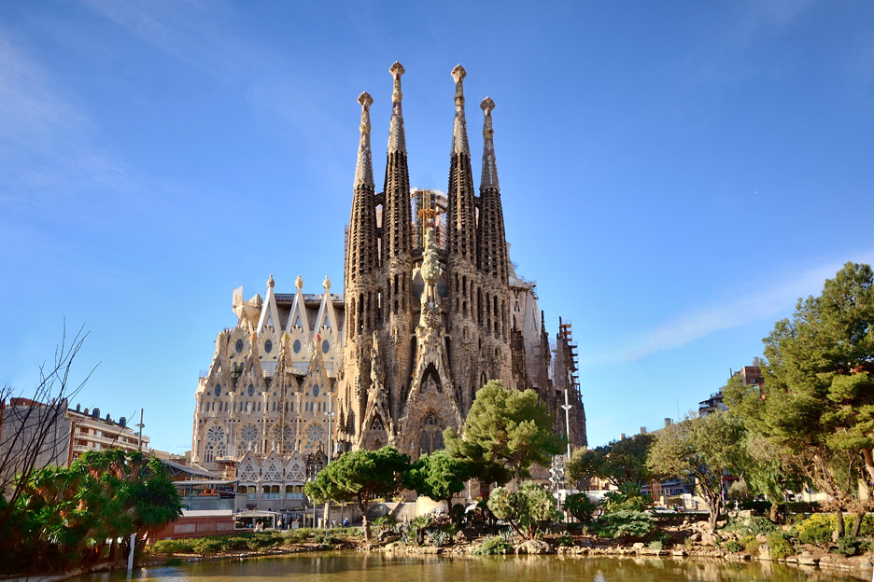  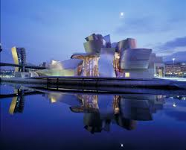

**day 1 Barcelona**

**shuttle transfer** from **Barcelona** airport to the hotel in Barcelona.

leisure time to enjoy the city.

overnight at hotel in Barcelona.

**day 2 Barcelona**

breakfast at the hotel.

**Barcelona** **sightseeing** based on a hop on- hop off bus.

*the tour will highlight all the things to do in the city so that you can hop on and off at your convenience at more than 44 stops. the key sights are included on the tour including the gothic quarter which is the centre of the old city of Barcelona. a great number of buildings are world heritage sites. especially remarkable is the work of architect Antoni Gaudi, which can be seen throughout the city; the Sagrada Familia cathedral, Casa Batllo, Casa Mila and Park Güell.*

overnight at hotel in Barcelona.

**day 3 Barcelona - Madrid**

breakfast at the hotel and check out.

**shuttle transfer** to Barcelona train station to take the train to **Madrid**.

**shuttle transfer** to the hotel & check in.

**Madrid** **sightseeing** based on a hop on- hop off bus.

*hop on the bus, put on your earphones, listen to the recorded commentaries and enjoy the streets, monuments and places of interest that you pass by. in addition, you will be able to hop off the bus wherever you want.*

overnight at hotel in Madrid.

**day 4 Madrid**

breakfast at the hotel.

**Toledo excursion** on regular basis.

*Toledo is one of the Spanish cities with the greatest wealth of monuments. known as the “city of the three cultures”, because Christians, Arabs and Jews lived together there for centuries, behind its walls Toledo preserves an artistic and cultural legacy in the form of churches, palaces, fortresses, mosques and synagogues. this great diversity of artistic styles makes the old quarter of the capital of La Mancha a real open-air museum.*

overnight at hotel in Madrid.

**day 5 Madrid - Bilbao**

breakfast at hotel and check out.

**shuttle transfer** to Madrid train station to take the train to Bilbao.   
**private transfer** to hotel.

**Bilbao sightseeing** based on a hop on - hop off bus.

*the great architectural and infrastructure projects have been the driving force of the urban and economic regeneration of the city; the Bilbao Guggenheim museum, the Euskalduna conference and music centre, Norman Foster's underground…*

overnight at hotel in Bilbao.

**day 6 Bilbao**

breakfast at the hotel.

full day **in San Sebastian**, regular basis.

*this city, also known as Donostia, is one of the most attractive cities on the Cantabrian coast. the* ***Museum of San Telmo****,* ***the Peine de los Vientos*** *(the wind comb) and* ***the Kursaal*** *are examples of how the city brings together modern and traditional features.*

overnight at hotel in Bilbao.

**day 7 Bilbao**

breakfast at the hotel and check out.

**departure transfer** to Bilbao airport.

**end of services**

**prices**

|  |  |  |  |
| --- | --- | --- | --- |
| **price per person & package** | **Nov - Mar** | **Apr – Oct** | **Jul - Aug** |
| **standard class** | **666 €** | **735 €** | **720 €** |
| child standard price (up to 12 yrs) | **240 €** | **250 €** | **240 €** |
| single supplement | **238 €** | **267 €** | **267 €** |
| **first class** | **711 €** | **780 €** | **750 €** |
| child first price (up to 12 yrs) | **198 €** | **215 €** | **215 €** |
| single supplement | **276 €** | **320 €** | **295 €** |
| **superior class** | **765 €** | **955 €** | **868 €** |
| child superior price (up to 12 yrs) | **105 €** | **105 €** | **105 €** |
| single supplement | **320 €** | **400 €** | **400 €** |

* prices per person based on double room & bb basis. taxes included. valid for minimum 2 traveling pax. prices for children sharing room with 2 adults.

* prices subject to availability and possible fluctuations in any of the requested services at the time of final booking.

**validity**: **until October 2020.**

inclusions:

|  |  |  |  |  |
| --- | --- | --- | --- | --- |
| **city & nights** | **transfers** | **sightseeing** | **meals** | **24h phone**  **assistance** |
| **2n Barcelona** | shuttle  apt-htl-apt | hop on hop off bus | breakfast |
| **2n Madrid** | shuttle  apt-htl-station | hop on hop off bus  half day Toledo excursion | breakfast |
| **2n Bilbao** | transfer station-htl-apt | hop on hop off bus  full day San Sebastian excursion | breakfast |

prices do not include:

* regional tourist tax.
* tips and guests´ extras.
* any other service not mentioned on the programme / itinerary described.
* train tickets, please find supplements below:
  + *AVE high speed train Barcelona – Madrid:   
    per person on tourist class:* ***from 109,70 €*** *(+ 4% handling fee)*
  + *ALVIA train Madrid – Bilbao:  
    per person on tourist class:* ***from 52,70 €*** *(+ 4% handling fee)*

**optional supplements**:

|  |  |
| --- | --- |
| **football tickets** | **on request** (prices from 48 € to 259 € average) |
| **Barça – Camp Nou stadium tour** | adult: 26 € child (6-13): 21 €  *\*with time and date given* |
| **Real Madrid stadium tour** | adults: 25 € children: 18 € |

* prices per person.

**itinerary & number of nights**

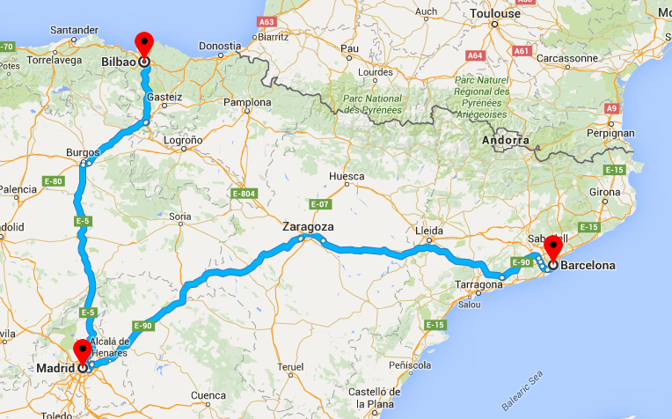

**2n**

**Barcelona**

**2n**

**Madrid**

**2n**

**Bilbao**